Strain Gauge Logger
Pete Jansen
2024-01-25

Document to describe the Strain Gauge Logger for Kelp Project

Requirements
Log Strain Gauge load data from LCM systems load shackle
LCM5096-5MCAB 4.75te Bow Shackle Load Cell c/w SubConn & 5m cab, sub 4500m

Battery powered,
10 month logging continuous at 1 sample/second
10 Hz sampling max

Design

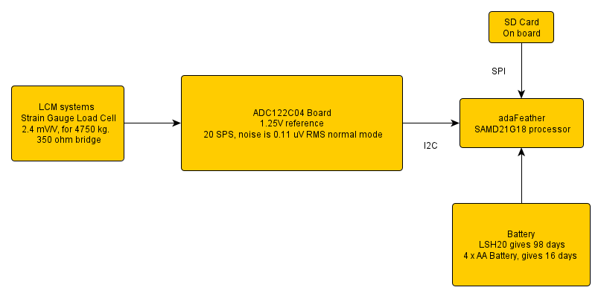

Using ATSAMD21G18 as processor with SD card attached,

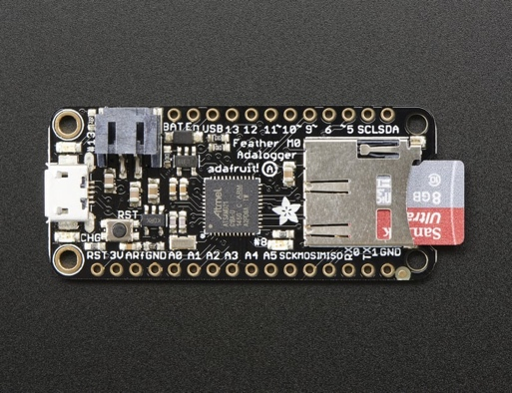

Use ADC122C04 as analog to digital converter, up to 2 ksamples/second.
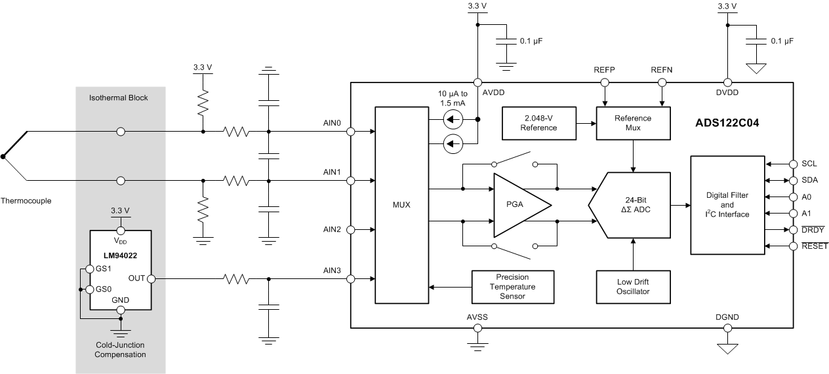

Noise is 0.11 uV rms at 20 sps, 2.048 V ref, normal mode.
0.11 * 1.25 / 2.048 = 67 nV.
Scale is 2.4 mV/V for 4.75 t,
with 1.25 V ref -> 3 mV for 4.75 t
0.63 mV / t -> 630 uV/t -> 630 nV/kg
-> noise is 0.1 kg rms.

Power

Feather standby current (no mods) 540 uA
Standby current (reg removed) 70 uA
IDLE2 8 MHz 2.6 mA
IDLE2 48 MHz 14 mA

Running, from Battery at 5.2 V, 970 uA, 1 sample/second

- LSH20 – 3.6 V to 2.0 V, 17 A.hr, to 3.3 V reduces to about 16.4 A.hr, capacity max at 5 mA at 20 degC. 17 A.hr @ 1 month ~ 23 mA (720 hrs).
- 4 x AA Duracell making 6V to 3.2V, 300 hrs at 10 mA, 3.016 A.hr. From 21 C to 0 C reduces service hrs from 25.4 to 20 hrs, nearly 20%.

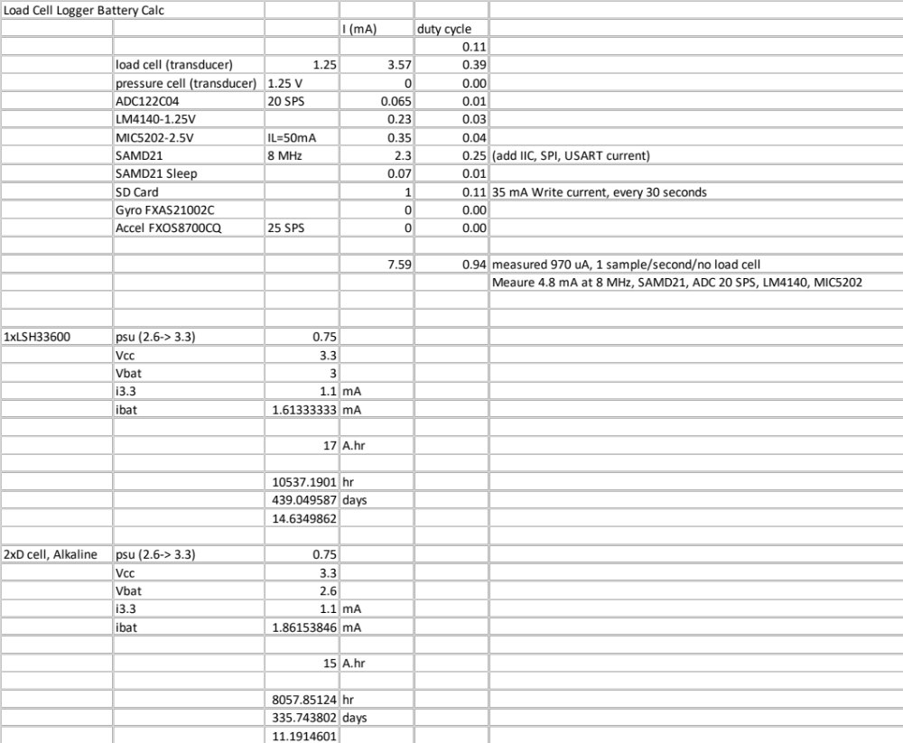

Using 2 x Alkaline D cells, at 1.1 mA 3.3 V current should get 330 days endurance, using Pololu 3.3V Step-Up Voltage Regulator U1V10F3

Software
Use Arduino development environment, which has Timer, I2C, UART, SD card, and DMA libraries

Use
uint8_t data_buffer[512 * 6 * 2];
6144 bytes data buffer, dual 3072 byte buffer which allows complete sector writes to SD card, ADC/DMA writes ½ buffer, write alternate ½ to SD card. Sample is 6 bytes, so 512 samples at 20 SPS is a write every 25 seconds.

DMA version
Sample cycle
State 0, Write ADC CMD register
State 1, txdma : send ADC START command
State 2, adc_isr : sens ADC RDATA command
State 3, txdma : read 6 bytes
State 4, rxdma : inc sample pointer, write ADC CMD reg, set state to 1

While the DMA version works, why make it so complex.

Direct version

Sample cycle
Wait Tick
Set power on to ADC
Wait power up, after 5 ms
Send config to ADC for sample,
Send START to ADC
Wait ADC ready
Send RDATA to ADC, and read 6 bytes

I2C reads and writes to look until finished, need to also timeout should ack not arrive.

Use internal SAMD21 RTC to keep time, need to set via serial connection, no battery backup.

Serial commands,

CMD cmds[] =
{
{"adc", cmd_adc, "display/set adc <rate> <gain>"},
{"time", cmd_time, "display/set time <YYYY-MM-DD hh:mm:ss>"},
{"regs", cmd_regs, "display all SAMD21 regs"},
{"sleep", cmd_sleep, "set can sleep"},
{"fcorr", cmd_fcorr, "display/set fcorr reg"},
{"debug", cmd_debug, "set debug level"},
{"ls", cmd_ls, "display card file list"},
{"startnow", cmd_start, "start sampling now"},
{"stop", cmd_stop, "start stop sampling"},
{"starttime", cmd_starttime, "set/display start time"},
{"startlater", cmd_startlater, "start sampling at starttime"},
{"set", cmd_set, "display settings"},
{"samplerate", cmd_sample, "display/set sample rate"},
{"text", cmd_text, "display/set deployment text note"},
{"file", cmd_file, "display/set file name %Y-%M-%DT%H%M.BIN"},
{"reg1", cmd_reg1, "display/set ADC reg1 - sets sample rate"},
{"format", cmd_format, "format card 'format yes' to format"},
{"sync", cmd_sync, "sync file"},
{"help", cmd_help, "command help, this message"}
};

Mechanical

Mount in SBE39 size housing, with connector in end cap, housing is 231.1 mm x 48.2 mm diam. Plastic housing is 600m depth rated.

Hardware updates 2024-01-25
Change connector to mini FIT,
Add I2C pull ups,
Make enable REF and ADC 2.5V Reg separate.

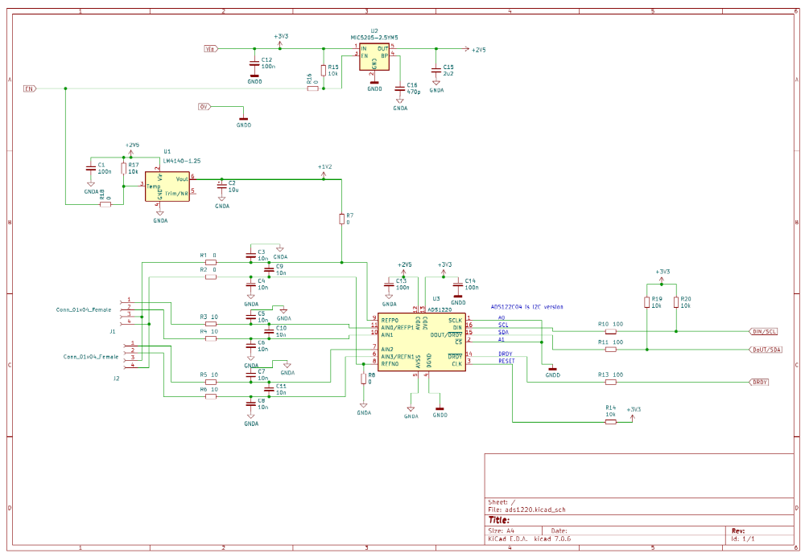

Board is 24 x 43mm
